AWS S3

(Simple Storage Service)

INTRODUCTION

* A cloud-based object storage service provided by amazon web services (AWS).
* It allows businesses and individuals to store and retrieve any amount of data, at any time, from anywhere on the web
* works by storing objects (which can be files, images, videos, or other types of data) in S3 buckets, which are unique containers for storing data.
* S3 is designed to be highly scalable, durable, and available
* used by businesses of all sizes across a wide range of industries, from start-ups to large enterprises.
* An S3 bucket is like a folder where you store your files in Amazon S3. You give it a unique name and can control who can access your files. Buckets are highly scalable, durable, and secure. They provide a simple and flexible way to store and manage your data in the cloud.

FEATURES

* S3 is a secure, flexible, and cost-effective cloud storage service.
* Data is stored as objects, which makes it easy to manage and retrieve.
* S3 offers multiple storage options to fit your needs and budget.
* S3 includes features like versioning and lifecycle policies to help manage your data and control costs.
* S3 has built-in security features like access controls and encryption to protect your data.
* S3 is easy to use and integrates seamlessly with other AWS services.

STORAGE CLASSES IN S3

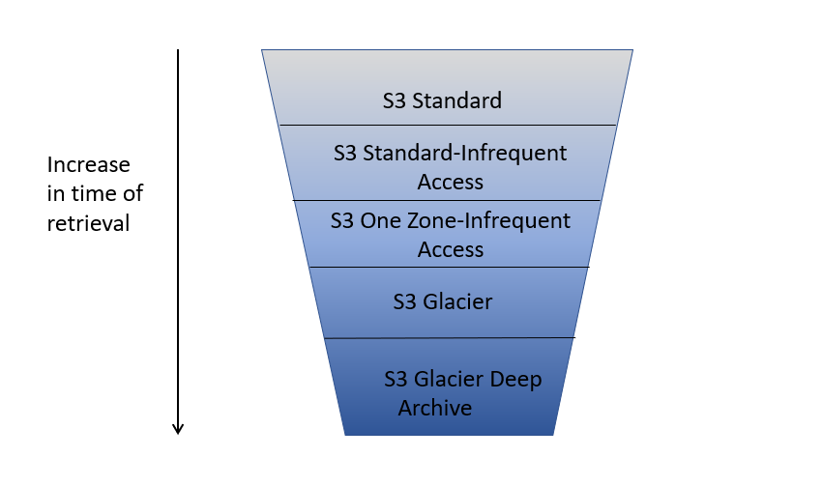

* S3 Standard: for frequently accessed data that requires low latency and high throughput
* S3 Standard-Infrequent Access (S3 Standard-IA): for data that is accessed less frequently, but requires immediate access when needed
* S3 One Zone-Infrequent Access (S3 One Zone-IA): for data that is accessed less frequently and can be recreated if lost
* S3 Glacier: for data archiving and long-term storage with lower costs, but longer retrieval times
* S3 Glacier Deep Archive: for data archiving and long-term storage with the lowest costs, but even longer retrieval times.

ACCESS CONTROL, ENCRYPTION, AND AUDITING

* S3 has security features to control access to your data, like access controls and encryption.
* Your data is protected while it's being transferred and while it's stored on S3 servers.
* S3 includes auditing capabilities to track who is accessing your data and detect any unauthorized attempts to access it.
* S3 integrates with AWS Identity and Access Management (IAM) to help manage access to your S3 resources.

INTEGRATION WITH OTHER AWS SERVICES

* IAM(Identity and Access Management) lets you control who can access your data in S3, so you can keep it private and secure.
* KMS(Key Management System) provides an extra layer of security for your data in S3 by managing encryption keys.
* CloudFront helps deliver your content to users around the world with low latency.
* S3 integrates with other AWS services like EC2 and RDS, which can make it easier to build and run scalable applications in the cloud.

S3 DATA FLOW ARCHITECTURE

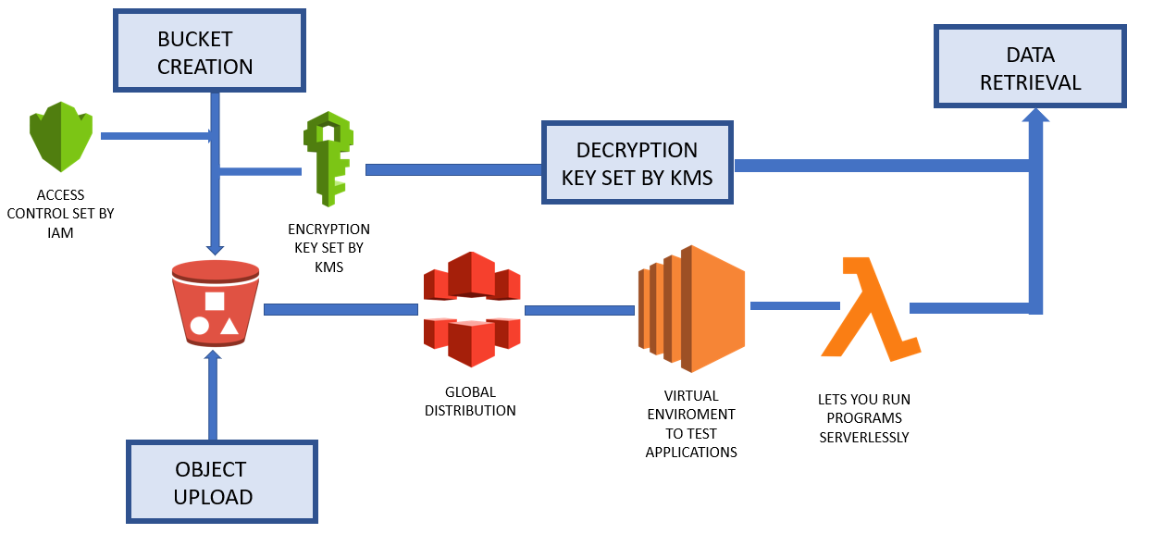

USE CASES

* You can use Amazon CloudFront to deliver your content from your bucket to users around the world quickly.
* You can use S3 to host static websites and serve images, videos, and other media.
* S3 can be used for backup and disaster recovery, so you can retrieve your data in case of an emergency.
* You can store and process large amounts of data for analysis using tools like Amazon EMR and Amazon Redshift.
* S3 can also be used for archiving, file sharing and collaboration, and storing and processing data from IoT devices.

**1.CREATING A BUCKET IN S3**

->Log into your [AWS web console](https://https/aws.amazon.com/console)

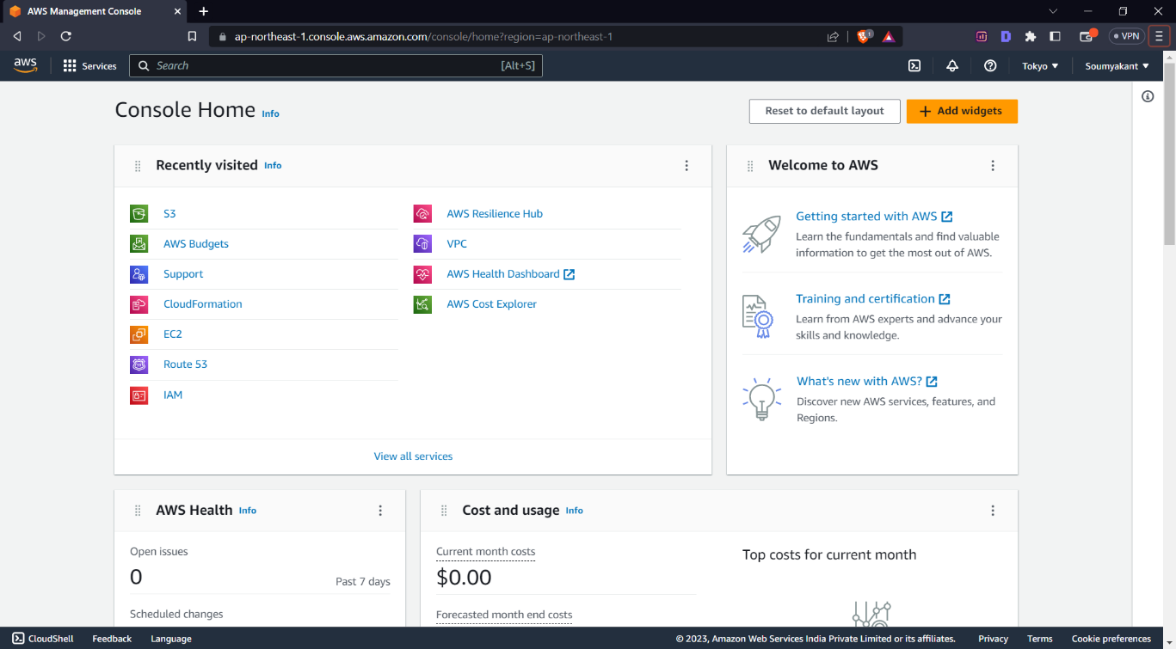

->and search for S3 service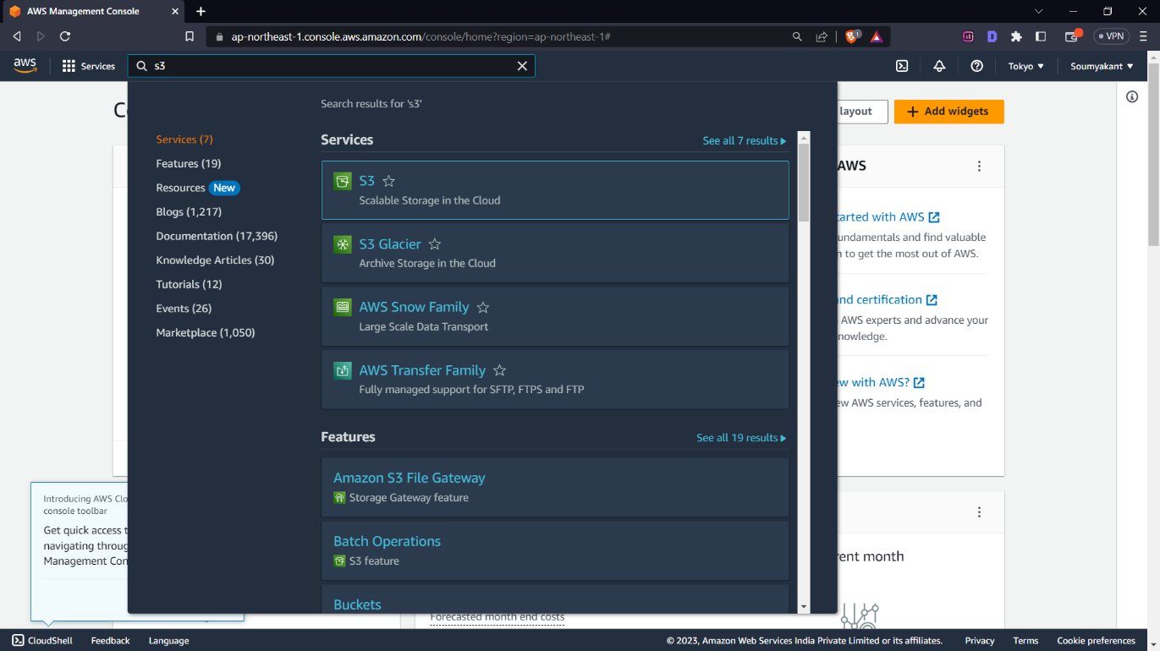

->The **S3 Dashboard** looks like the image below

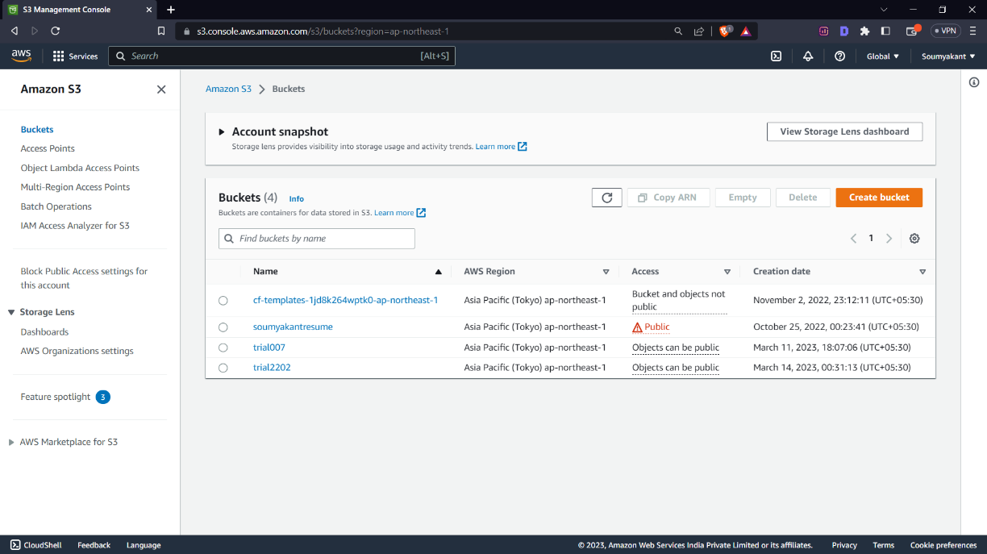

->Click on Create Bucket. Give it a globally unique name.

->Select the appropriate region to deploy your resource.

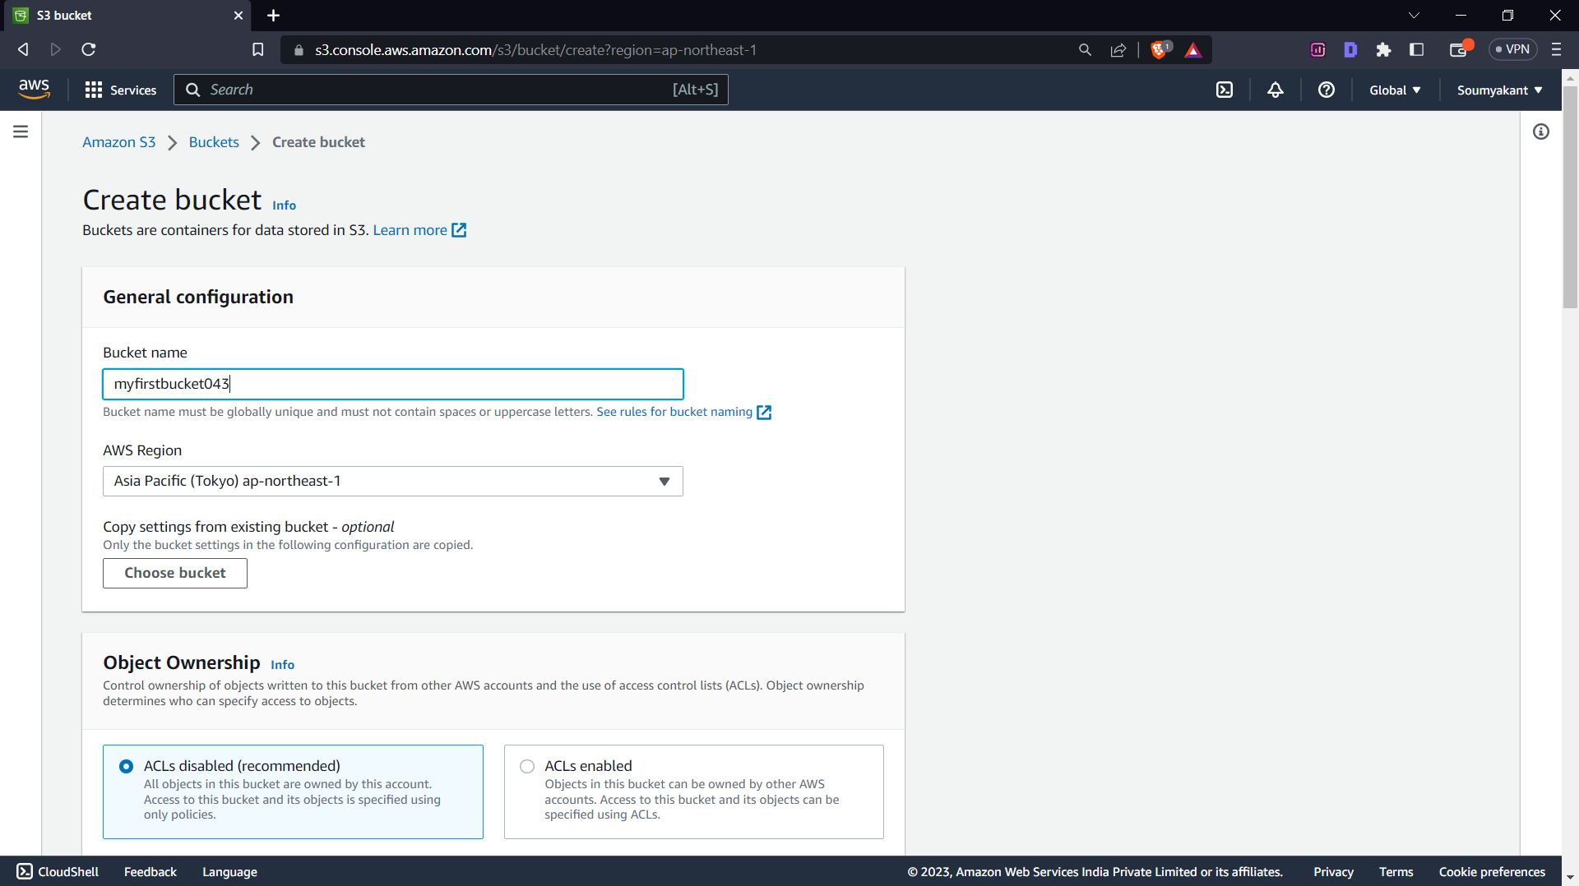

->Uncheck Block Public Access and check the Acknowledgement term.

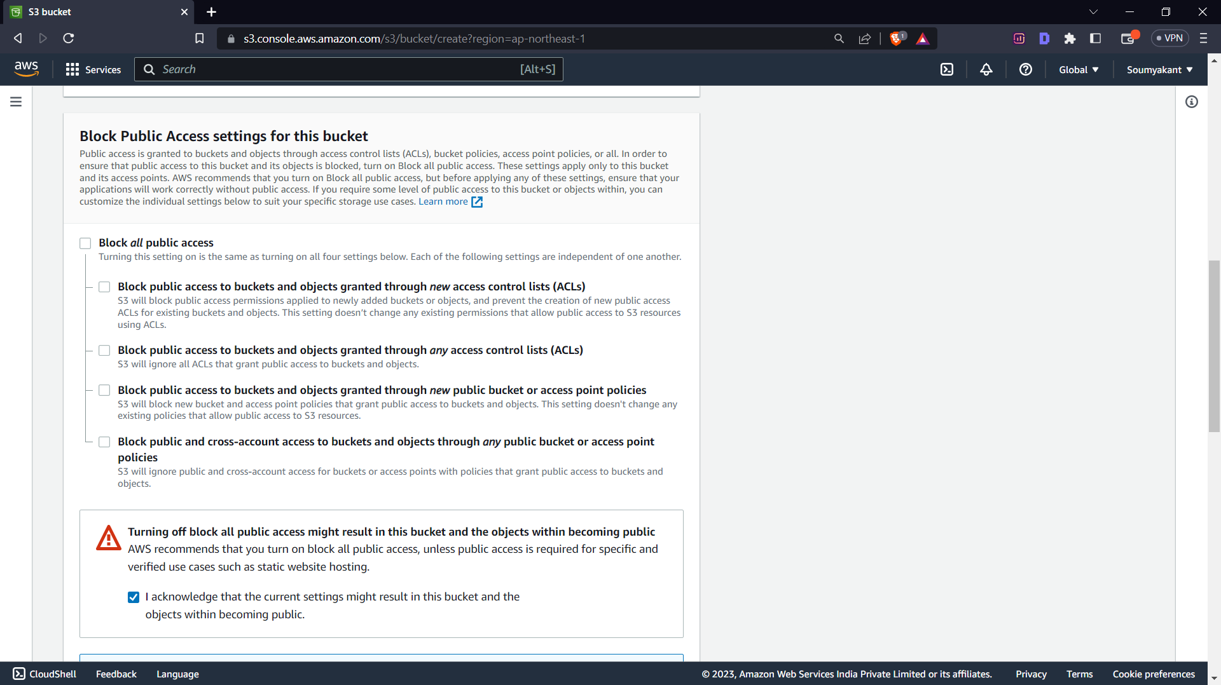

->Click on create bucket.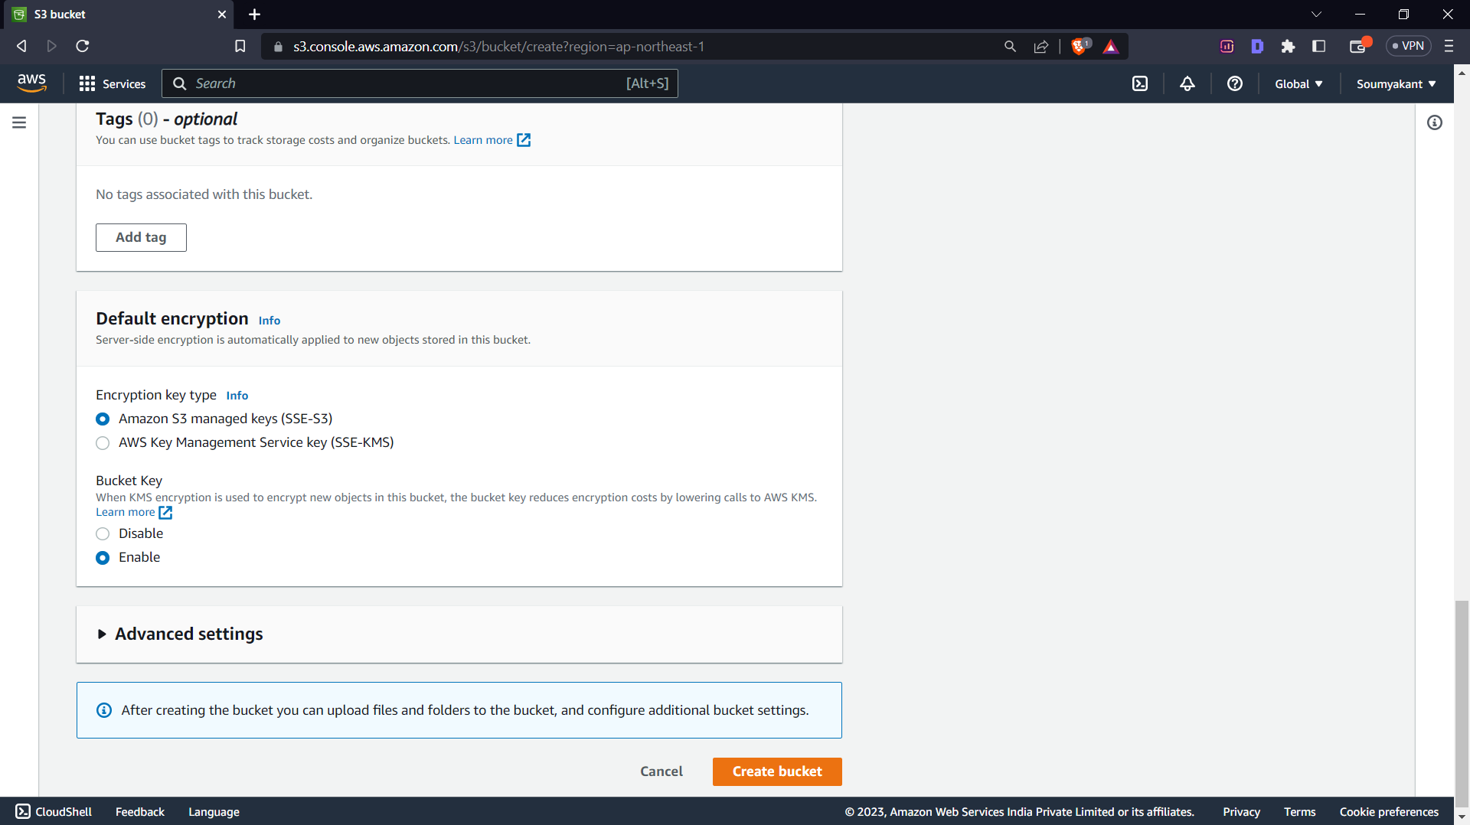**2.Setting up Bucket Policy and Permissions**

->GO back to the dashboard.

->Click on the bucket name,

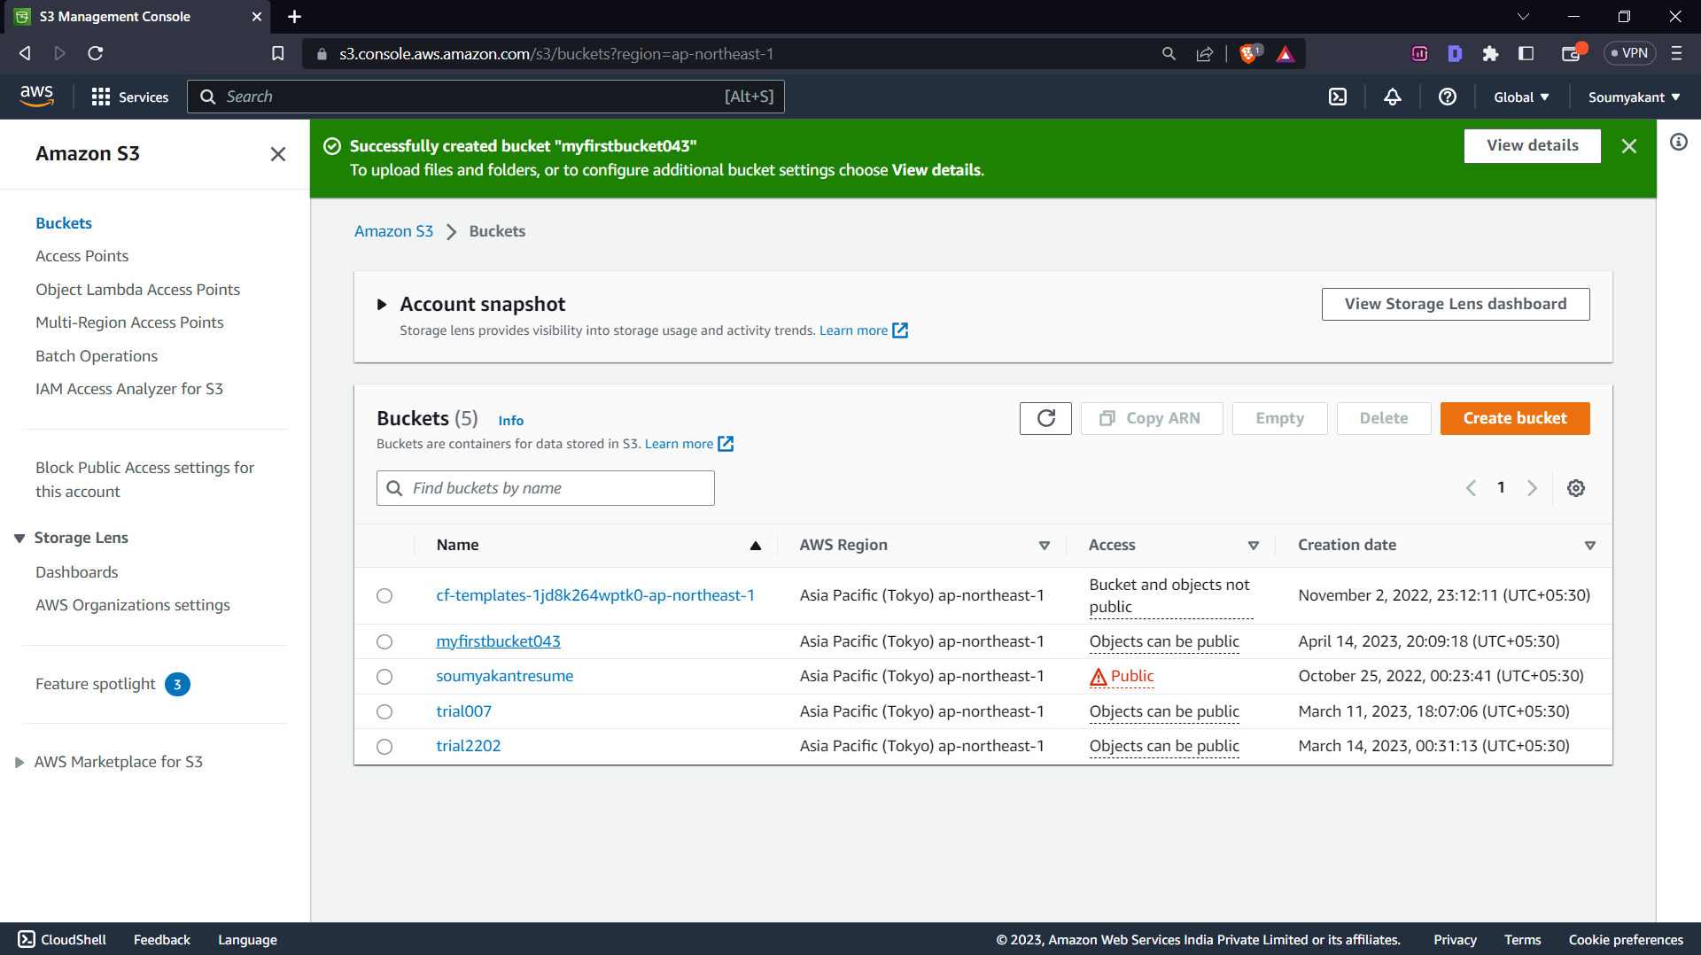

->then click on the Permissions tab

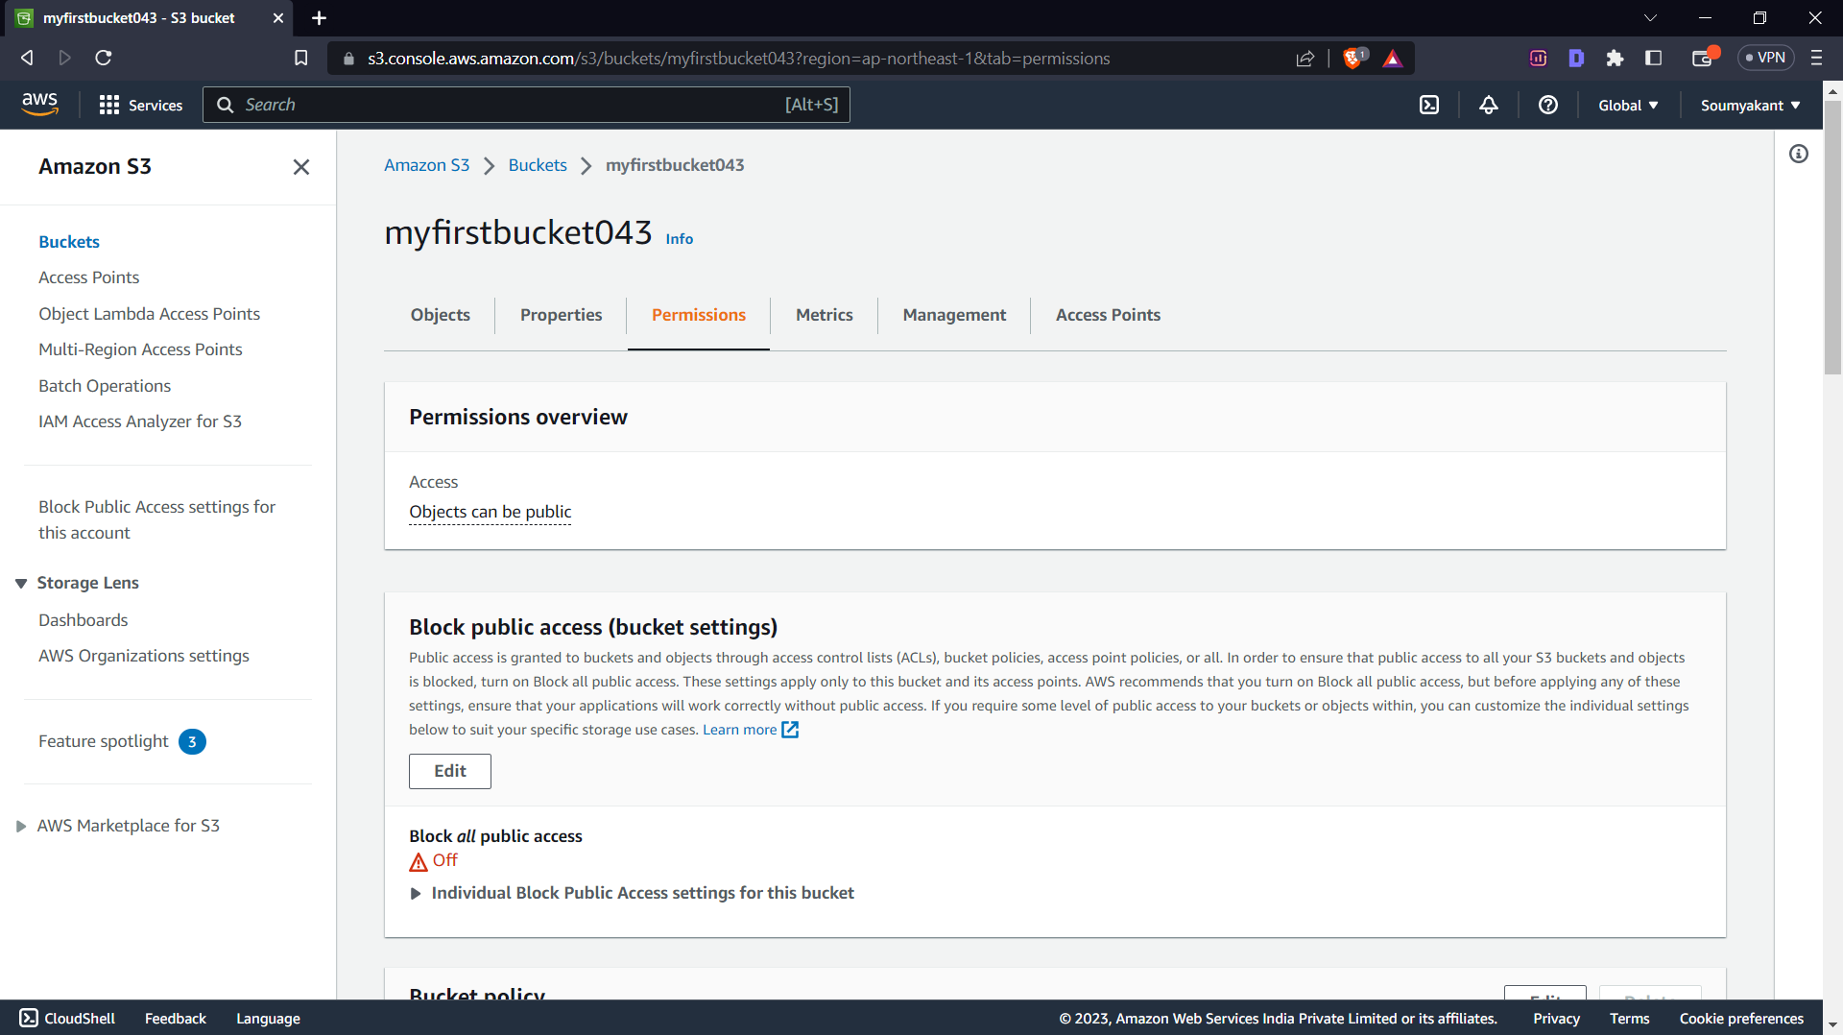

->Click on the edit option in Bucket Policy

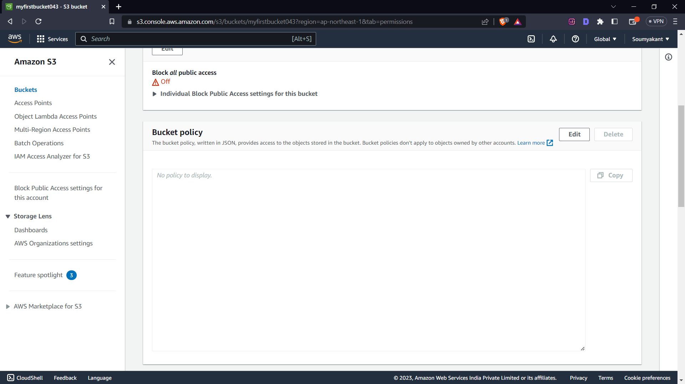

->Click on Policy Generator

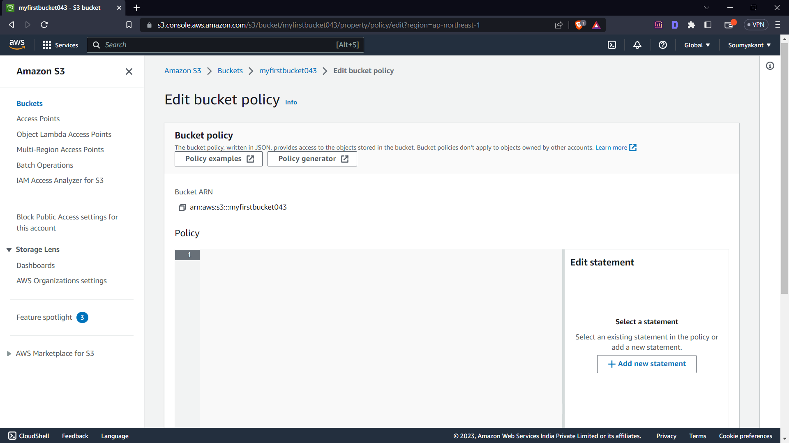

-> Select the policy type as S3 Bucket Policy.

->Type “*” in the principal option as our object is public.

->Choose GetObject and GetObjectVersion in the action option.

->Copy the Bucket ARN from the previous tab and add “/*” in last.

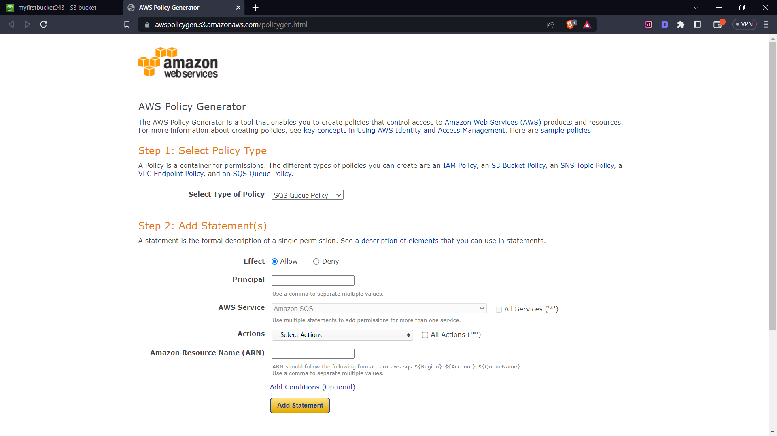

->Click on the generate option and Copy the code

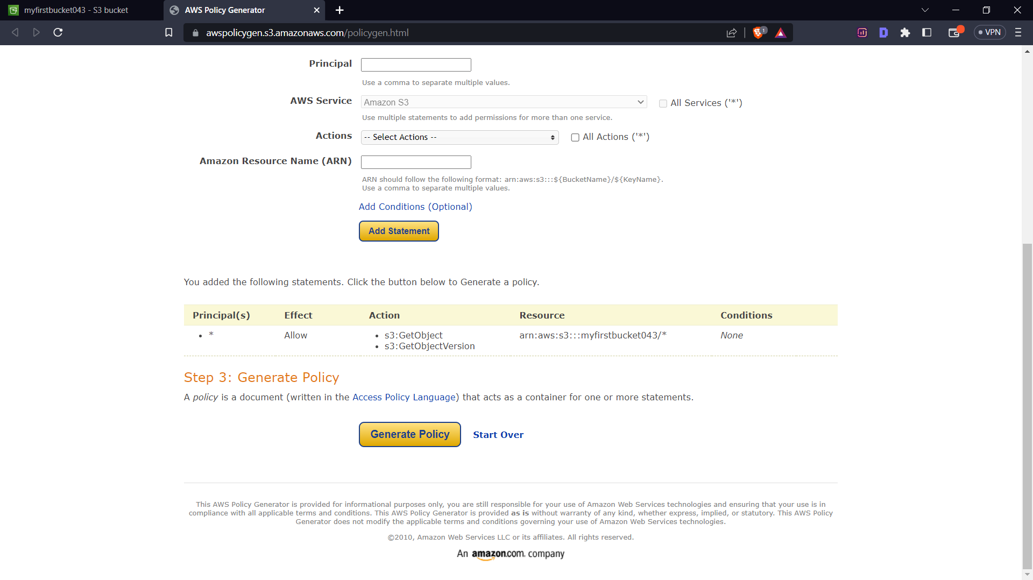

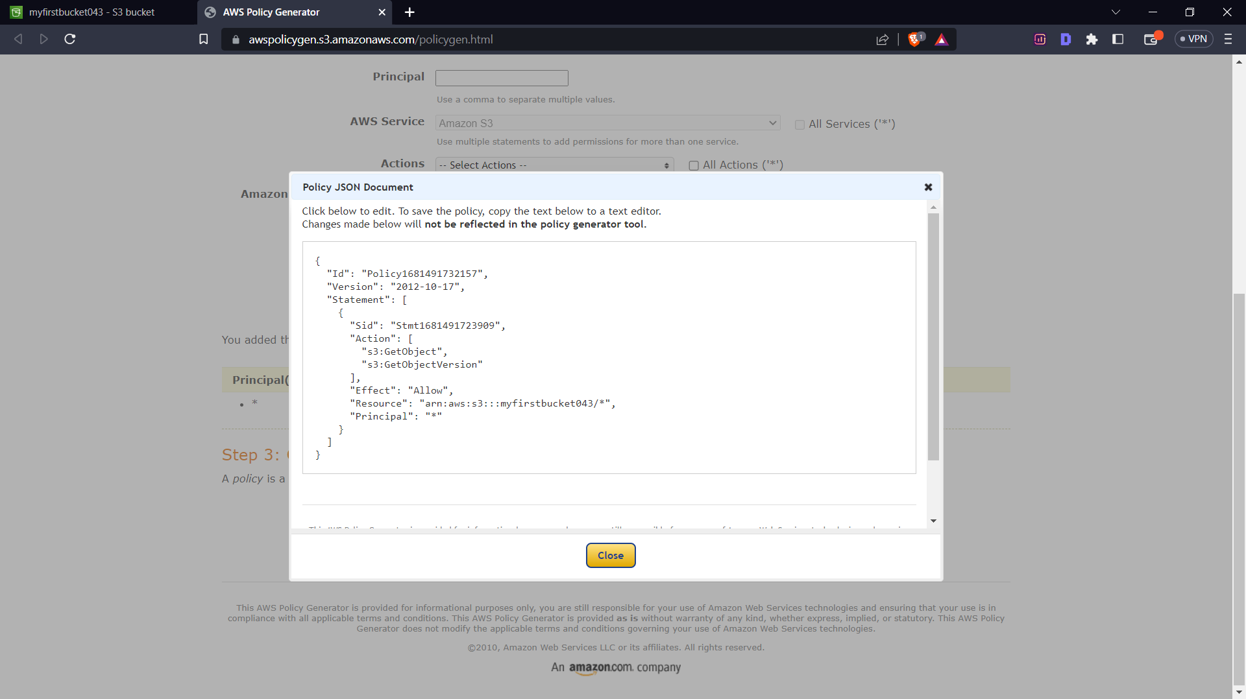

->Paste the code in the Bucket Policy and save changes.

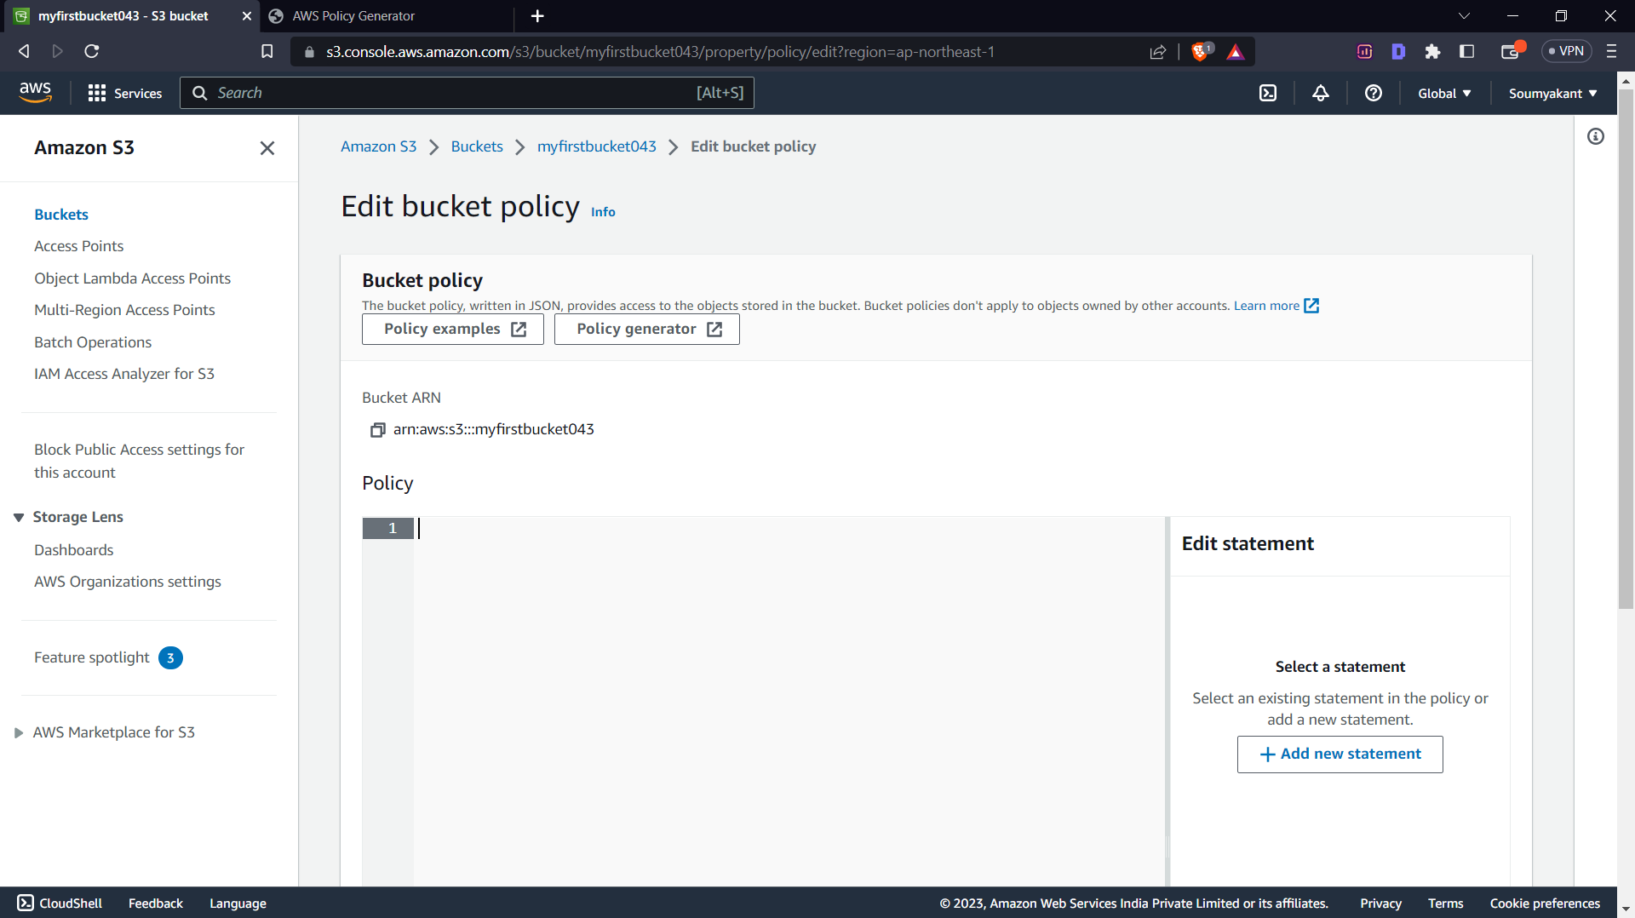

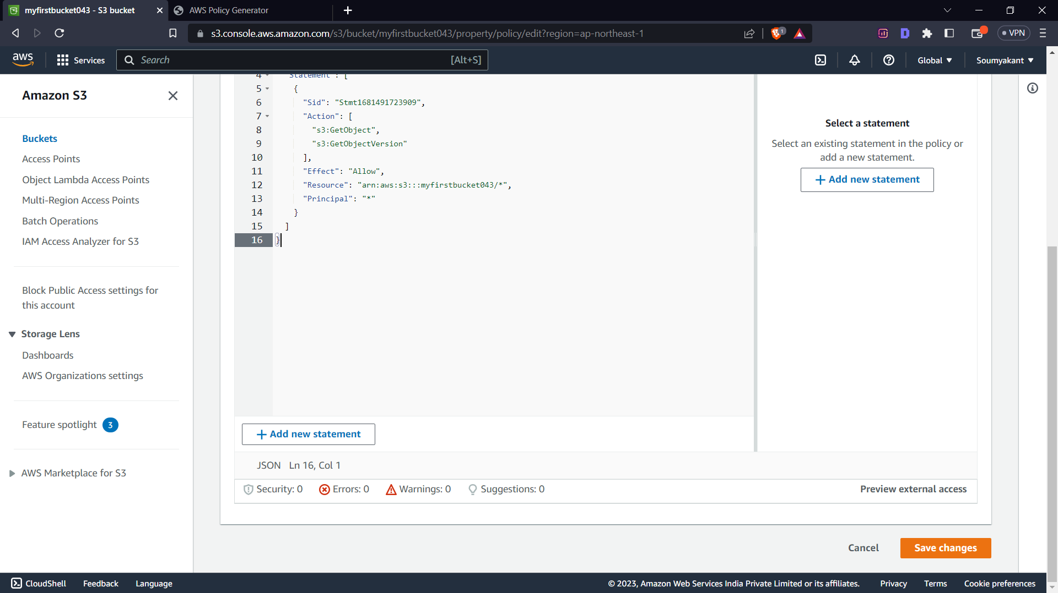

**3.UPLOADING FILES**

->Click on the object tab, then click upload

->Click on add files

->Select your file that you want to upload

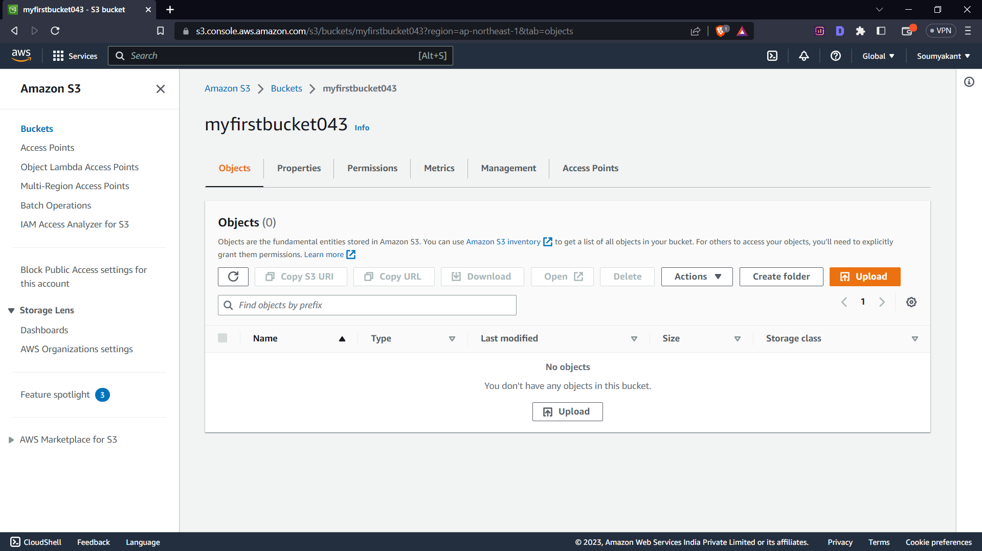

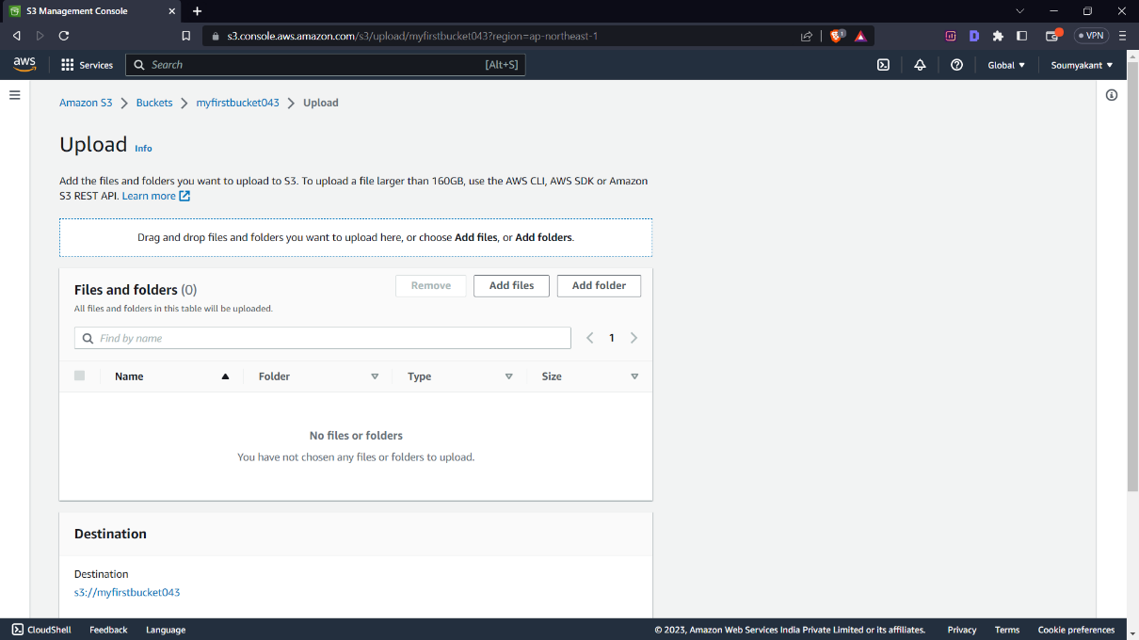

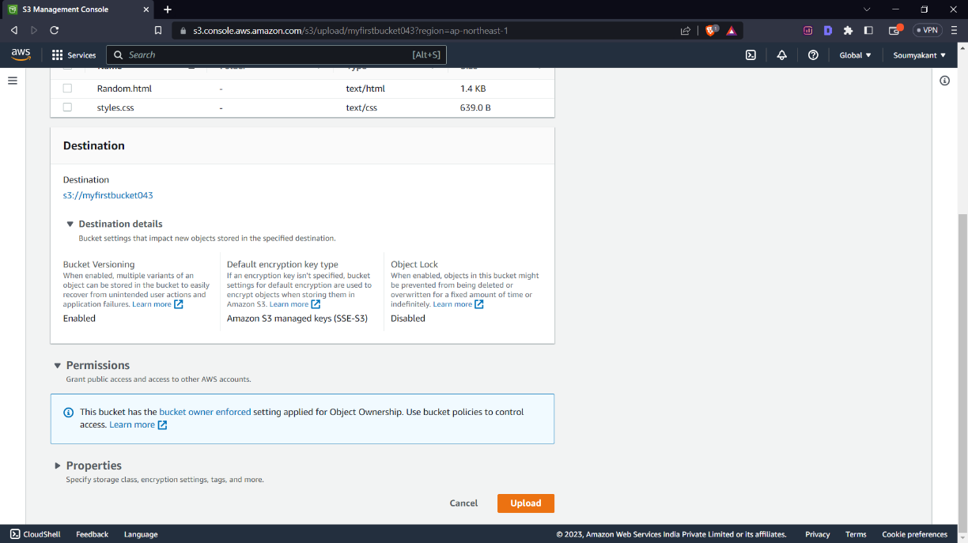

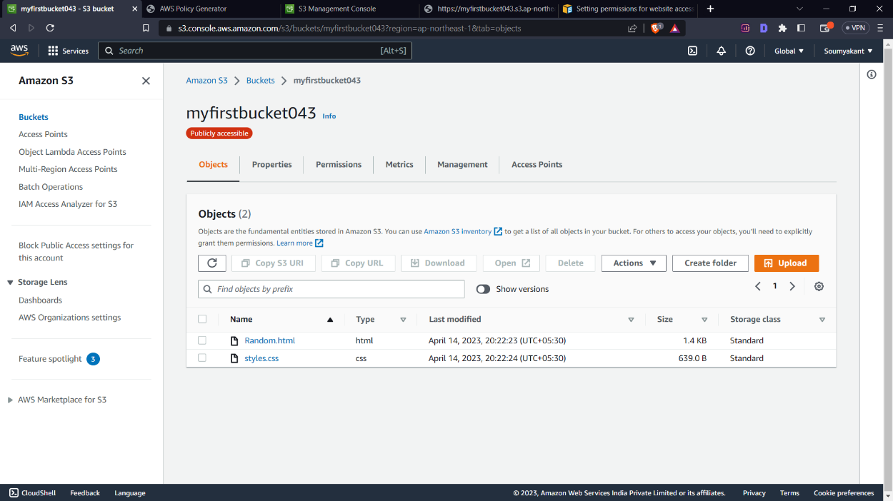**3.Setting up Static webpage**

For deploying a static webpage, after uploading necessary files, you have to specify the index page in properties.

->After uploading, go back to your Bucket page and click on properties



-> Scroll down to end and click the edit option in Static website hosting

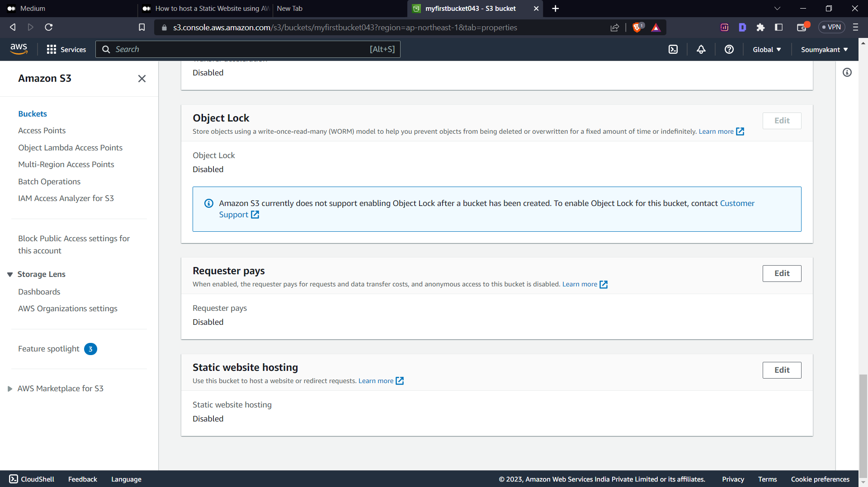

->Click Enable option then specify your index document (Random.html) and Click save changes.

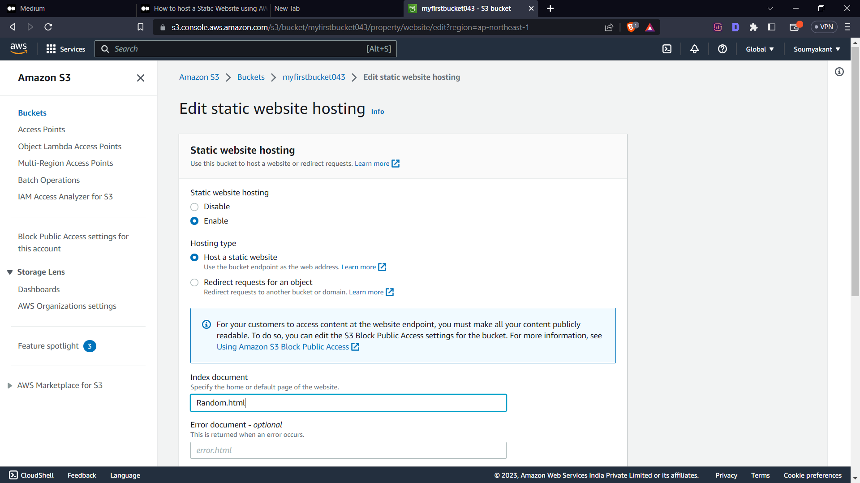

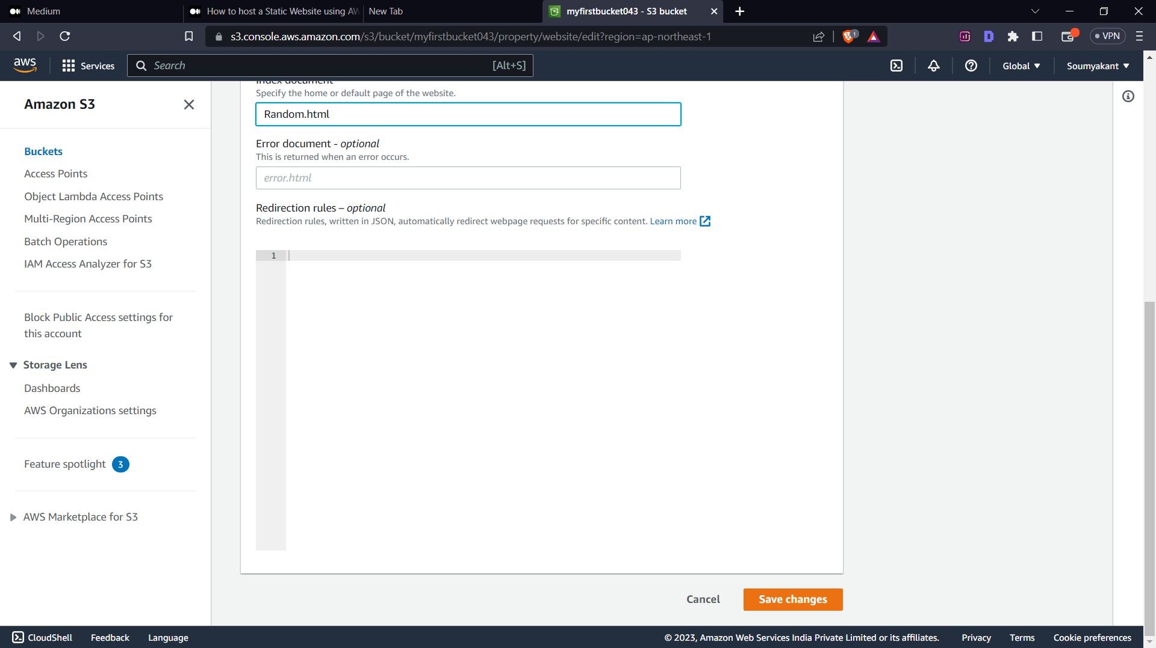

->After that Click the object tab

-> then click your index page

->Now you have successfully deployed your static webpage using AWS S3.

Now you can see your website just by copying the Object URL and pasting it in an another tab`s URL section.

->Go to object tab and click on your index page(Random.html).

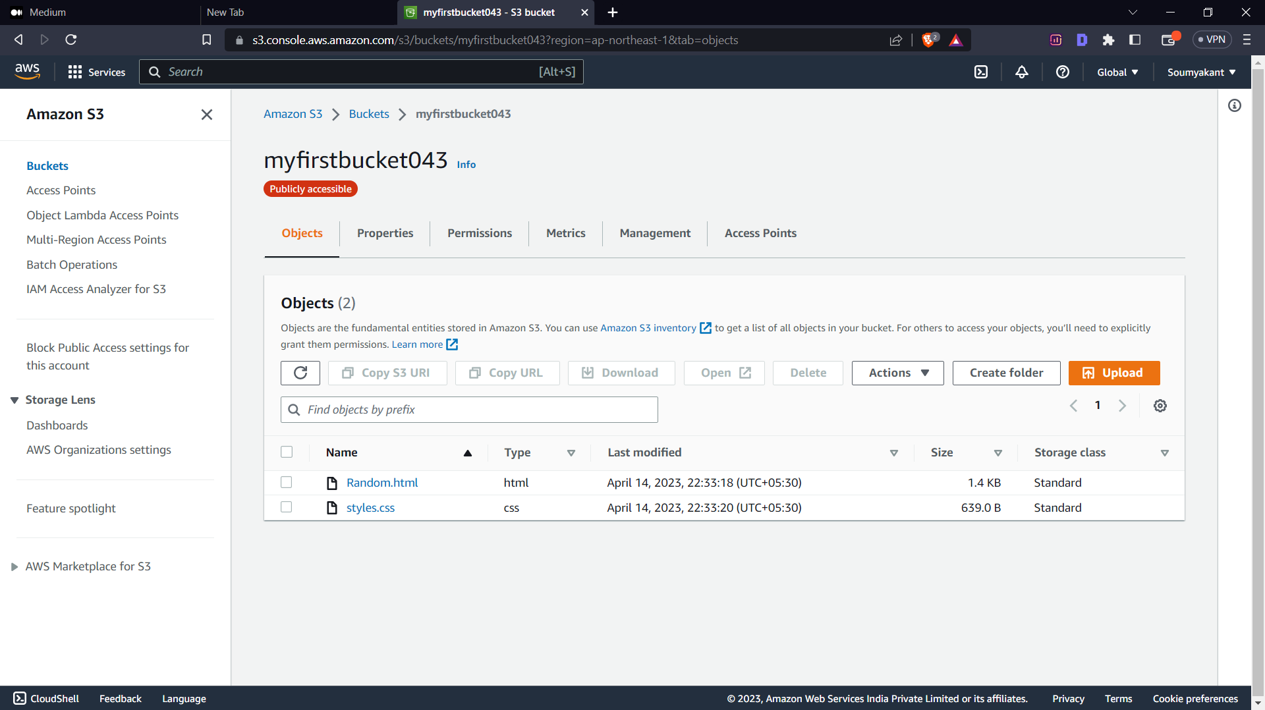

->In properties, copy the object URL.

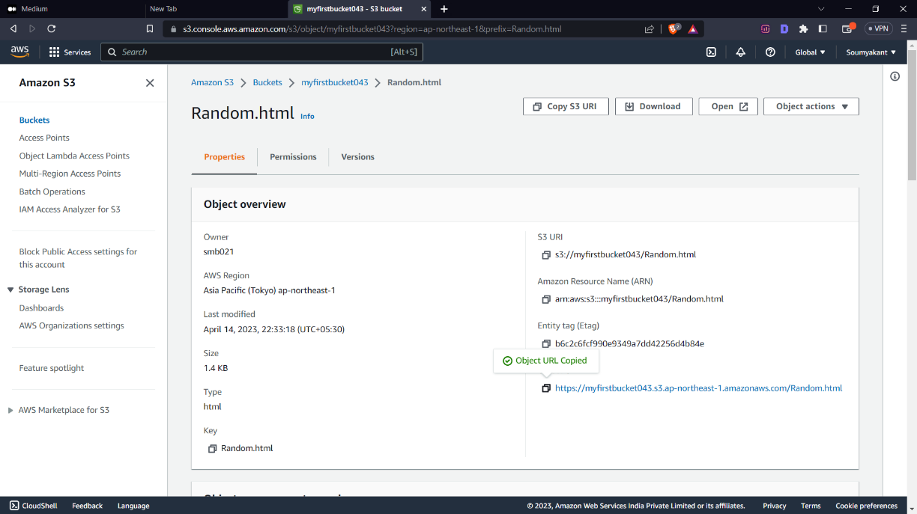

->Paste it in another tab`s URL section and click enter.

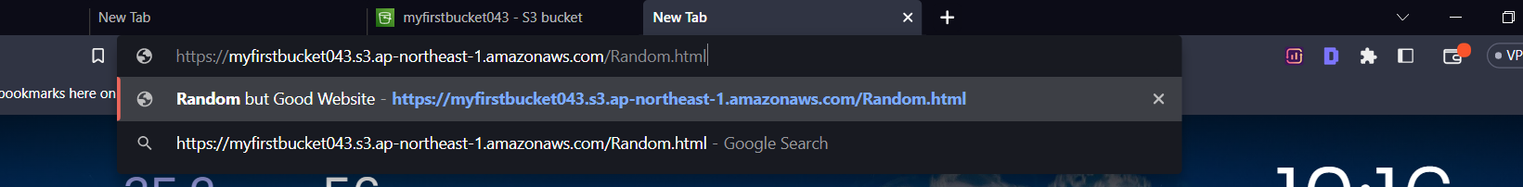

->and Voila! The page that appears on the screen is your website deployed from AWS S3.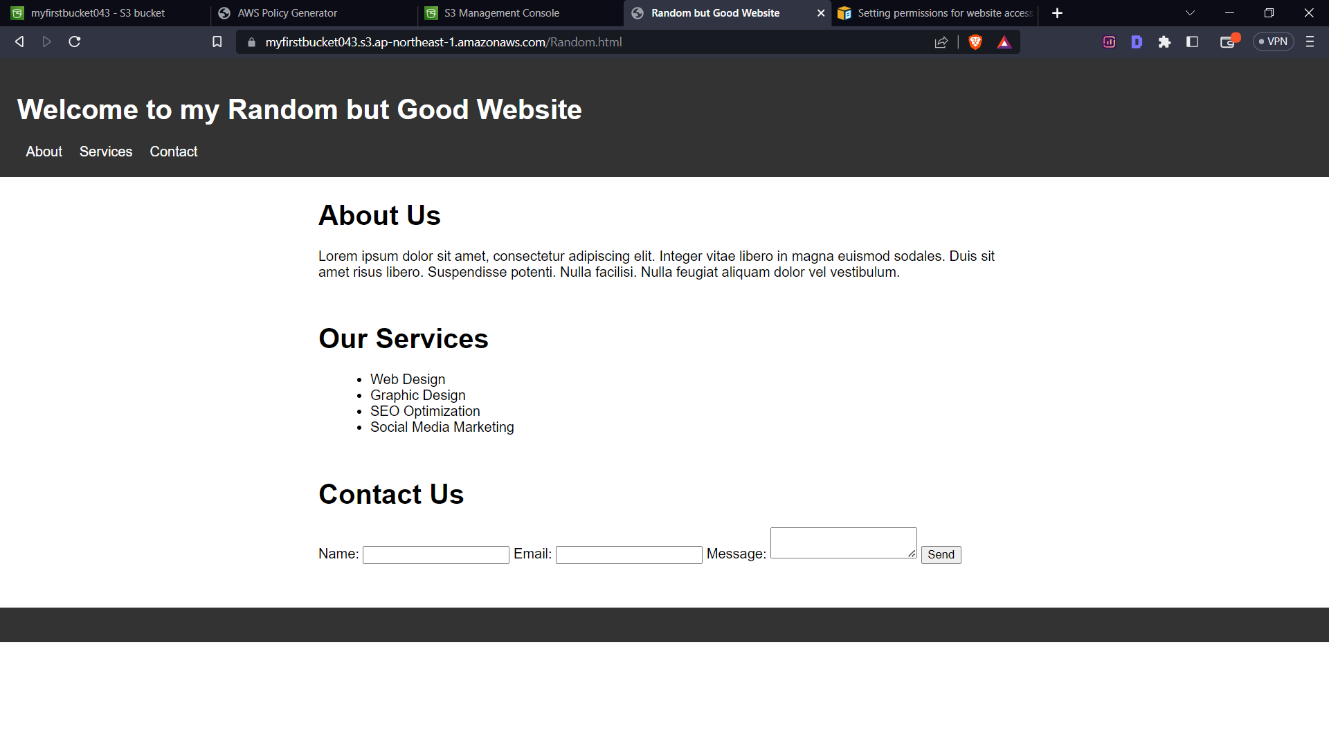

CONCLUSION

* AWS S3 is a powerful, flexible, and cost-effective cloud storage service.
* S3 is designed for high availability and scalability, with features such as multi-region replication and automatic scaling.
* S3 is already used for a variety of use cases, from content distribution to big data analytics.
* The potential uses for S3 will only continue to grow as more data is generated and more businesses move to the cloud.

In the future, S3 could be used for even more advanced data management and analytics tasks, as well as for powering cutting-edge applications such as machine learning and artificial intelligence